**Week 5 Lab Report**

This document contains the template you will use to complete this assignment. Save the file by adding your last name to the filename (e.g. CIS246_W5_Lab_Report_EK_Smith.docx).

Follow the steps for this week’s lab. At various points in the instructions, you will be asked to answer a question or capture a screenshot to document your work – type your answers and place screenshots into this document, then submit this completed Lab Report to the appropriate weekly Dropbox.

***Screenshots***

#1. Ping from Windows 7 based on your name (12 points)

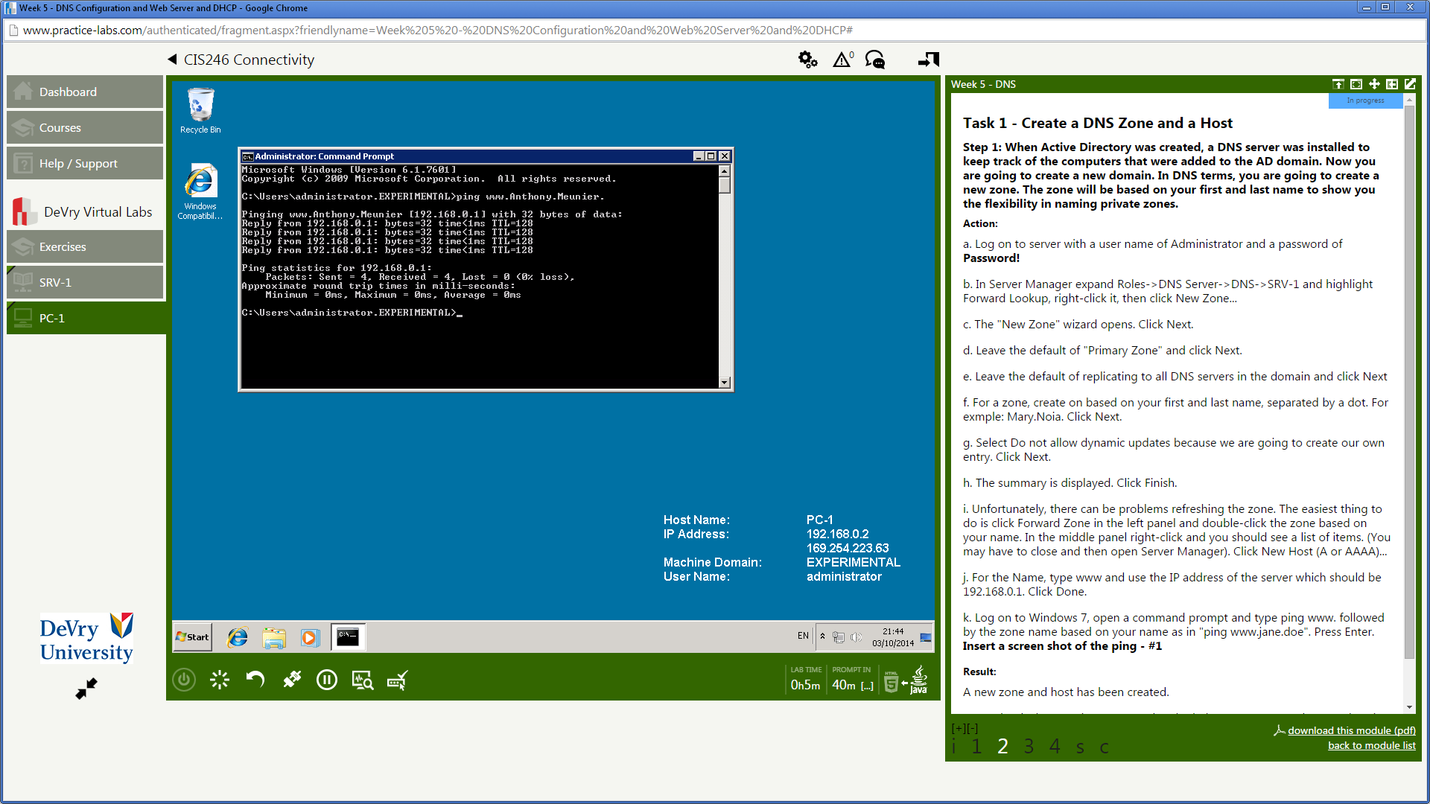

#2. Web Server Role (12 points)

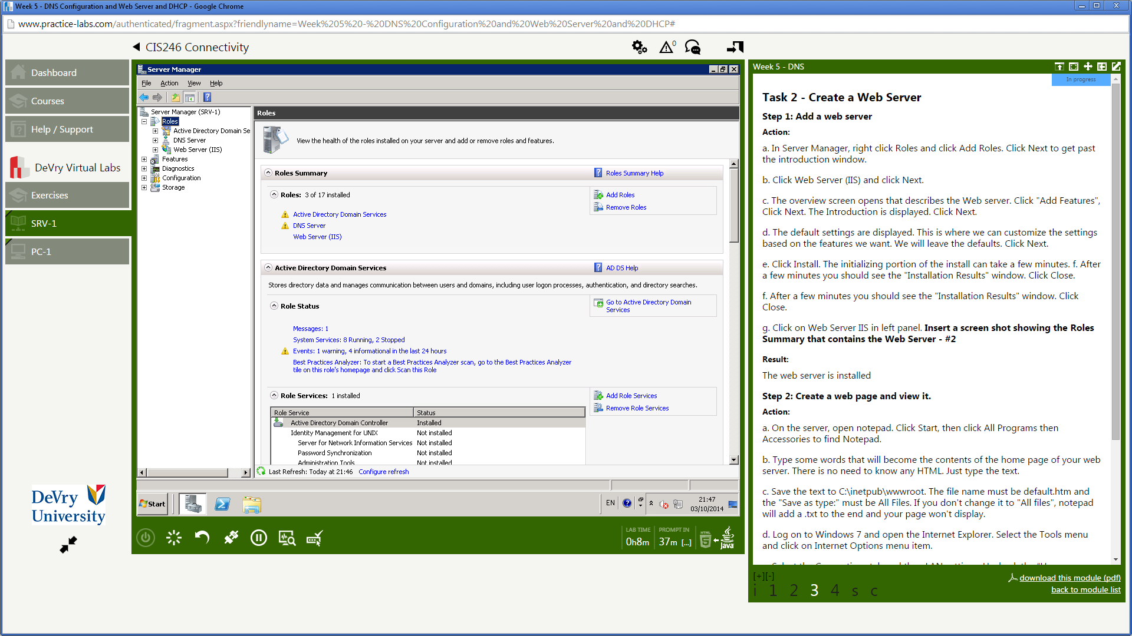

#3. Web page with URL based on your name (13 points)

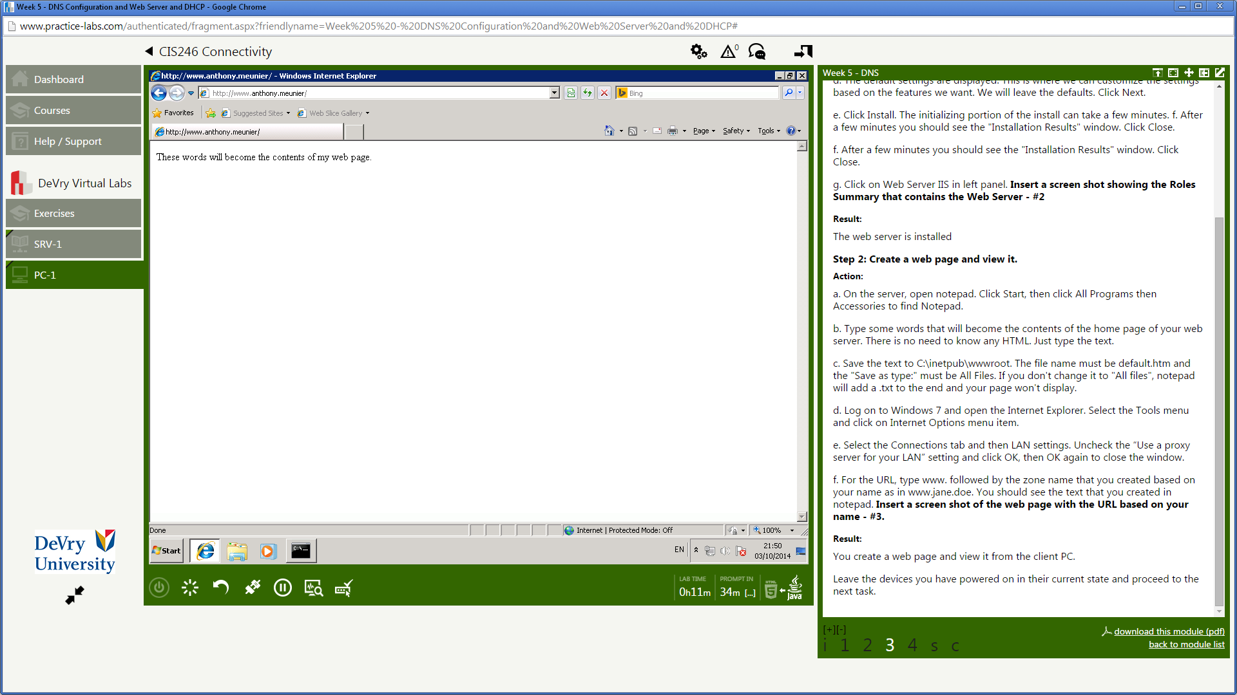

#4. ipconfig information showing DHCP server and IP address. (13 points)

